**DETECTION AND CLASSIFICATION OF BRAIN TUMOR USING MACHINE LEARNING**

Minor project report submitted in partial fulfillment of the requirement for the degree of Bachelor of Technology

in

# Computer Science and Engineering

By

Abhiti Labroo (191225)

Aman Gupta (191228)

**UNDER THE SUPERVISION OF**

Prof. (Dr.) AMAN SHARMA



Department of Computer Science & Engineering and Information Technology

# Jaypee University of Information Technology, Waknaghat, 173234, Himachal Pradesh, INDIA

**TABLE OF CONTENT**

| **Title** | **Page No.** |
| --- | --- |
| **Declaration** | **I** |
| **Certificate** | **II** |
| **Acknowledgement** | **III** |
| **Abstract** | **IV** |
| **Chapter-1 (Introduction)** | **1- 3** |
| **Chapter-2 (Feasibility Study, Requirements Analysis and Design** | **3- 7** |
| **Chapter-3 (Implementation)** | **8 -21** |
| **Chapter-4 (Results)** | **22-24** |
| **References** | **25** |

**DECLARATION**

I hereby declare that this project has been done by me under the supervision of **Dr. Aman Sharma** Jaypee University of Information Technology. I also declare that neither this project nor any part of this project has been submitted elsewhere for award of any degree or diploma.

**Supervised by:**

**Dr. Aman Sharma**

Assistant Professor (SG)

Department of Computer Science & Engineering and Information Technology

Jaypee University of Information Technology

**Submitted by:**

**Ms. Abhiti Labroo**

191225

Computer Science & Engineering Department

Jaypee University of Information Technology,Solan

**Mr. Aman Gupta**

191228

Computer Science & Engineering Department

Jaypee University of Information Technology,Solan

**CERTIFICATE**

This is to certify that the work which is being presented in the project report titled **Detection and Classification of brain tumor using Machine Learning** in partial fulfillment of the requirements for the award of the degree of B.Tech in Computer Science And Engineering and submitted to the Department of Computer Science And Engineering, Jaypee University of Information Technology, Waknaghat is an authentic record of work carried out by **Abhiti Labroo,**(191225) and **Aman Gupta,**(191228) during the period from January 2022 to May 2022 under the supervision of **Dr.Aman Sharma** Department of Computer Science and Engineering, Jaypee University of Information Technology, Waknaghat.

Abhiti Labroo

191225

Aman Gupta

191228

The above statement made is correct to the best of my knowledge.

Dr. Aman Sharma

Assistant Professor (SG)

Computer Science & Engineering and Information Technology

Jaypee University of Information Technology, Waknaghat,

**ACKNOWLEDGEMENT**

Firstly, I express my heartiest thanks and gratefulness to almighty God for His divine blessing makes it possible to complete the project work successfully.

I am really grateful and wish my profound indebtedness to Supervisor **Dr. Aman Sharma,Assistant Professor (SG)**Department of CSE Jaypee University of Information Technology, Wakhnaghat. Deep Knowledge & keen interest of my supervisor in the field of **Machine Learning** to carry out this project. His endless patience, scholarly guidance, continual encouragement, constant and energetic supervision, constructive criticism, valuable advice, reading many inferior drafts and correcting them at all stages have made it possible to complete this project.

I would like to express my heartiest gratitude to **Dr. Aman Sharma,** Department of CSE, for his kind help to finish my project.

I would also generously welcome each one of those individuals who have helped me straightforwardly or in a roundabout way in making this project a win. In this unique situation, I might want to thank the various staff individuals, both educating and non-instructing, which have developed their convenient help and facilitated my undertaking.

Finally, I must acknowledge with due respect the constant support and patients of my parents.

Abhiti Labroo

(191225)

Aman Gupta

(191228)

**ABSTRACT**

In many medical applications that are utilized for diagnosis, defect detection and classification in medical imaging has become an emerging field. The detection of tumors in an MRI is basic since it offers data about deviant tissues, which is expected for a quick and secure treatment arrangement. Early discovery of brain tumors is basic in clinical practice to determine whether the cancer could possibly become harmful. In view of the multifaceted design and assortment of malignancies, MRI mind cancer recognizable proof is a troublesome endeavor. Low grade tumors, such as grade-1 and grade-2, and high grade tumors, such as grade-3 and grade-4, are the two categories of brain tumors. The expression "benign" alludes to a second rate mind growth.A high-grade growth is additionally alluded to as threatening.A benign tumor is not equivalent to a cancerous tumor. Thus, it doesn't spread to different regions of the brain.The malignant tumor is a cancerous tumor in its nature which basically results in its rapid and endless spreading.

Doctors are the main gateway for human inspection of the MRI scans for the brain tumor which is infact a traditional approach. The sheer amount of data through these scans are immeasurable, hence this procedure is quite unfeasible. Therefore, it is essential and critical to have automatic, reliable and precise classification strategies in place to lessen or reduce the fatality rate of the patients. Tumor detection and classification approaches have been developed to aid radiologists in saving time and achieving demonstrated accuracy.

In this project, with the assistance of a comparison Convolutional Neural Network (CNN) and VGG-16 model under machine learning the tumor is detected and is classified into its types like gliomas, meningioma, and pituitary tumors. The accurate and precise distinction among the three types of brain tumors signify a very crucial phase of the medical diagnostic procedure and later successful evaluation of patients.Machine learning and image classifiers are two of the significant ways to efficiently detect cancer or tumorous cells in the brain through MRI.

**Chapter 01: INTRODUCTION**

* 1. **Introduction**

Brain tumor is one of the most thorough and painstaking sicknesses in clinical science. A powerful and productive investigation has forever been one of the top priorities of the radiologist and doctors in the inopportune period of brain tumor development. Histological grading, it is a strategy in view of a stereotactic biopsy test, is viewed as one of the significant principles and is one of the ways for recognizing the grade or the severity of the brain tumor. Biopsy system requisites the neurosurgeon or doctors to bore a little hole into the skull which aids the neurosurgeons to collect the tissues for sampling.This method pertains many gamble factors, including excessive bleeding from the lump or brain tumor and brain might be subjected to infections, seizures, acute headaches, stroke, unconsciousness and even untimely death.Yet, the major issue with the stereotactic biopsy is that it isn't fully or 100 percent exact which may results in about a real signs visible blunders followed by a wrong clinical administration or diagnosis of the sickness.

Cancer biopsy is thought to be difficult for brain tumor patients so accordingly new painless imaging procedures like Magnetic Resonance Imaging (MRI) have been widely utilized in detection of brain tumor growths. In this way, advancement of frameworks for the predictions and its further classification in context of the grade of tumors with the assistance of MRI information has arisen massively.

It very well may be clearly seen that the imaging methodology like in Magnetic Resonance Imaging (MRI), the correct understanding of the growth tumor cells and its distinction with its close by delicate and sensitive tissues is a particularly considered a difficult and tedious task which might be possible due to the presence of low enlightenment in imaging modalities of information or a few intricacy or details and difference of cancers like unstructured shape, feasible size and capricious areas of the growth.Brain tumor detection in clinical imaging utilizing ML has turned into the new field in a few clinical analytic applications. Its application in the discovery ofbarin tumors in MRI is extremely significant as it gives data about strange tissues which is vital for arranging therapy. Studies in the new literature have additionally revealed that programmed mechanized recognition and diagnosis of the sickness, in view of clinical imaging study and it could be considered a decent option as it would save radiologist time and furthermore get a tried precision. Moreover, in the event that these algorithms can give robust and quantitative estimations of growth portrayal of tumors, these robotized estimations will significantly support the clinical administration of brain tumors by liberating doctors from the weight of the manual portrayal of growths.

The ML based calculations in radiology and other medical science fields assume a significant part to analyze the illness in a lot easier manner as never done and thus giving a plausible option in contrast to careful biopsy for brain tumor.During the course this project, the endeavored at detecting and classifying the brain tumor and contrasting the outcomes classification of brain tumor with use of pre-trained Keras models like VGG16 and using Convolutional Neural Network architecture.

* 1. **Objective**
* To study the existing tools and techniques available for classification of Brain Tumor.
* To implement deep learning algorithms for classification of brain tumors in MRI images.
* Testing and validation of implemented deep learning models using test dataset.
* Finally, Comparing existing deep learning models for brain tumor classification.
  1. **Motivation**

The motivation for this work is the nature of this disease as brain tumors are observed as abnormal and unnatural growth of cells within the brain or central spinal canal. Brain tumors occurred when the cells were dividing and growing abnormally. It is appearing to be a solid mass when it is diagnosed with diagnostic medical imaging techniques. Its uncertainty makes it even more troublesome. The exact cause of brain tumors is not clear and neither is the exact set of symptoms defined, thus, people may be suffering from it without realizing the danger.

The symptoms of a brain tumor depend on the location, size and type of the tumor. It occurs when the tumor compresses the surrounding cells and gives out pressure. Besides, it is also occurring when the tumor blocks the fluid that flows throughout the brain. The common symptoms are having headache, nausea and vomiting, and having problems in balancing and walking.The main motivation to work in this field of healthcare was to develop an automated system for enhancement, segmentation and classification of brain tumors.

The system can be used by neurosurgeons and healthcare specialists. The system incorporates image processing and pattern analysis, and is expected to improve the performance measures of brain tumor screening. The primary goal of medical imaging projects is to extract meaningful and accurate information from these images with the least error possible. The proper combination and parameterization of the phases enables the development that can help in the early diagnosis or the monitoring of the tumor identification and locations.

* 1. **Language Used**

For the comparison model Python 3 is utilized,which is a statistical numerical programming language and was chosen because of the accompanying reasons:

1. The python data structure is better in comparison to other mathematical programming languages like MATLAB.

2. Python code is more reduced and meaningful.

3. Python is an efficient way that is provided to us as an open source and also provides more and varied graphic packages and data sets Keras with TensorFlow as backend.

* 1. **Technical Requirements (Software and Hardware)**

**1.5.1 Software Requirements:** Python 3 was the language used to build the project for the reasons stated above. Kaggle was utilized to get the dataset. GitHub and

StackOverflow was utilized for reference if there were any occurrence of programming language structure mistakes.Google Colaboratory, it is an open-source Jupyter Notebook that interacts with high GPU offices. Google Colab is a free Jupyter notebook environment that requires no setup and runs entirely on cloud. With Colab, one can compose and execute code, save and offer analysis, access strong processing assets, for nothing from the program. Jupyter Notebook is a strong method or technique for emphasizing and composing the python programs for information analysis. As opposed to composing and changing a whole code, one can compose lines of code and run them all at once.

**1.5.2 Hardware Requirements:**

Processor: Intel® Core™ i5-10300H

Memory Installed on device (RAM) 8.00GB

System Type: 64-bit Operating System

* 1. **Outcomes**

The outcome for the comparison model, would be whether the MRI scan of a patient does have a brain tumor or not and also it would further classify into the major forms it's found in. The model has attained an accuracy of 93.558%. With the fairly high accuracy, the doctors would be able to judge which type of tumor and according to the severity would also matter and immediate care for the patients could be provided.

**Chapter 02: Feasibility Study, Requirements Analysis and Design**

**2.1 Feasibility Study**

**2.1.1 Problem Definition**

The MRI images acquired from MRI machines give two dimensional cross sectional of the brain. However, the MR images acquired did not extract the tumor from the image. Thus, the image processing is needed to determine how severe the tumor is and it basically depends on the size and its location. As Brain Tumor has various types and its detection and classification for a lot of data when done manually could be highly erroneous, therefore is automated tumor detection and further on classification is considered highly favorable.

**2.1.2 Problem Analysis**

The analysis of the problem statement was done with the help of a literature survey. Extensive

literature survey helped in better analysis about what all work was done previously, the techniques and algorithms used and also what all performance metrics used. The main objective of the literature review was to determine what exists in the scholarly literature regarding the topic and the literature survey of various journal articles would further help in finding what all different models were developed and what were the research findings from them and it would further help us compare and contrast them.

**Related Work**

**Badža and Barjaktarovi´c (2020)**[1] – According to the authors the model used T1-weighted contrast-enhanced MRIs as a dataset. The Brain Tumor classification model was designed by the authors using a Convolutional Neural Network performed on the platform MATLAB R 2018 a. K-fold cross-validation methods to test or validate the network’s performance. Two distinct methodologies were executed, furthermore, both comprised of 10-fold cross-validation. The principal approach was to arbitrarily partition the information into 10 equivalent parts so every cancer classification was similarly present in each part, alluded to as record-wise cross-approval.The subsequent methodology was to haphazardly partition the information into 10 equivalent segments where the information from a sole subject must be viewed as in one of the sets.Each set, hence, contained information or data from several subjects no matter what the cancer class, alluded to as subject-wise cross-approval.An Adam optimizer was used to train network,with a cluster or batch size equivalent of 16 and information was rearranged or data was shuffled for each cycle.Performance metrics that were used in this paper were accuracy, recall, F1-score, and precision and they were visualized with help of the confusion matrix.

**Irmak (2021)**[2]**-** In this model, four unique datasets, which were accessible from public information domains, were utilized. RIDER, REMBRANDT, TCGA-LGG and3064 T1-weighted contrast-enhanced images were four datasets that were used.The first of these CNN models utilized in this paper was to recognize the brain tumor; consequently, it concludes whether a given MRI picture of a patient has a cancer or not.This task described above was referred to as classification one. The second convolutional neural network model arranges the tumor into its further types. This task was referred to as classification two. The third CNN model made by the authors intended to classify the glioma brain tumors into three grades as Grade II, Grade III and Grade IV. This assignment was called classification three.The performance of the proposed model is assessed involving the five fold cross - validation process for all the three order assignments. The dataset is partitioned into five-overlay out of which 4 sets are utilized for preparing and the excess one is utilized for testing. Performance metrics that were used in this paper were accuracy, specificity, sensitivity, precision and AUC of ROC curve.

**Krizhevsky et al. (2012)** [3]– The model accomplished the outcomes in image classification in view of training a large, deep convolutional neural network to classify the enhanced images in the 2010 contest that was called ImageNet LSVRC into different classes.On the test information, the authors managed to accomplished first and top fifth error rates which was impressively better compared to the past outcomes.To make training faster, the author used non-saturating neurons and an extremely effective GPU execution of the convolution operation. To decrease the overfitting in the fully-connected layers the authors of the proposed model utilized an as of recently evolved regularization strategy called dropout that ended up being extremely viable.

**Jue et al. (2020)** [4]**-** Image processing and data augmentation were methods applied on a dataset. It was a small dataset of MRI images.The dataset was prepared through a basic eight convolutional layer for the CNN model. The contrast was made for the CNN model accuracy with three pre-trained models that were VGG-16, ResNet-50, and Inception-v3 and they were based on transfer learning concepts. During the phase of image processing of this model the authors proposed to remove dark edges from the images and they were cropped and only the brain portion from MRI images were taken. The technique used for the above implementation was canny edge detection technique which comes under OpenCV. Data augmentation was applied on the training dataset as the dataset was very small, this was done by adding adjustments to the MRI scans by rolling out minor improvements, for example, flipping, rotating, and changing brightness. According to the author the CNN model had fairly high accuracy on its training and testing dataset and its overall accuracy was fairly high when compared with Keras pre-trained models mentioned above for the same dataset.

**Szegedy et al. (2015)** [5] - As per the authors who developed a profound convolutional neural network design called Inception, which was liable for setting the new model for arrangement and diagnosis in a challenge in 2014 which was called ImageNet visual recognition. The primary accomplishment of this proposed model was the better use of the computing resources inside the network. This was accomplished by an architecture that takes into consideration increasing the depth and width of the network while maintaining the computational budget of the model consistent. The outcomes yielded strong proof that approximating the normal optimal sparse structure by readily available dense building blocks is a feasible strategy for working on neural networks for vision.

**He et al. (2015)** [6] -The author in this model presented the ResNet, which utilized skip connections and batch normalization.It was introduced as a residual learning system to facilitate the training of networks that are considerably more profound than those utilized beforehand. It was unequivocally reformulated as learning residual functions regarding the layer inputs, rather than learning unreferenced capacities.It gave extensive observational proof signifying that these residual networks are more straightforward to streamline, and acquire precision from impressively increased depth.

**Amina et al. (2017)**[7]**-** In this model, brain tumor diagnosis and its classification, a dataset was gained from public and nearby datasets that comprise anomalous and odd MRI scans.The rarities in MRI scans were removed like skull, background, scalps and eyes were eliminated and excluded from the area of interest. Brain Surface Extractor method technique was used by the authors to remove non important regions. It was utilized to distinguish the edges and perform morphological techniques such as erosion. Three varieties of kernels of Support Vector Machine were applied by the author on benchmark datasets for the correlation. The results with 5 and 10 fold cross validation at linear kernel with measures like accuracy , sensitivity and specificity for HARVARD dataset. Though on account of the RIDER dataset obtained accuracy, AUC, sensitivity and specificity were all 100% for the cubic kernel of the SVM for 25-fold cross validation.

**Rehman et al. (2020)** [8] **–** The authors in this model used three datasets for the proposed model for training and its validation. BRATS 2015, BRATS 2017, and BRATS 2018 were the chosen ones. The proposed methodology by the authors was majorly divided into three major steps: fiesta and foremost one was new convolutional neural network architecture which was basically build upon brain tumor extraction, the second one was the pre-trained VGG19 which was based on extraction of deep features, and lastly pearson correlation when combined along with FNN features selection which was used for final classification. Various parameters were utilized by the author for validation of the dataset like accuracy, frequency of error that is error rate, and computation time. The result according to the authors represented that the accuracy of the proposed model selection technique was increased after 3 - dimensional convolutional neural network segmentation when contrasted to original images but it resulted that the computation time of the segmented approach almost doubled when the comparisons to original images were made when they were provided to the pre-trained model for training.

**Simonyan and Zisserman (2014)**[9]-The impact of the convolutional network profundity on its precision in the huge scope image recognition setting was explored by the authors during their research. The primary commitment was an intensive assessment of networks of increasing depth using architecture with quite small convolution filters(3X3),which showed or mirrored that a huge enhancement for the earlier arrangements could be accomplished by pushing the depth to 16–19 weight layers training more modest forms of VGG with less weight layers.

**Ghahfarrokhi and Khodadadi (2020)**[10] **-** For this particular model, the pre-processing played an important role. Those that did not have important data were removed, and whatever were the important regions of interest they were determined.For determination of the tumor position fuzzy c-mean algorithm was implemented by authors. T1-weighted contrast-enhanced MRI scans were used as the input for the algorithm of the proposed model by the authors. Calculations were made for texture and nonlinear features for the dataset. In the last advance, three classifiers, specifically support vector machine, k-nearest neighbor, and pattern net, were applied to arrange benign and malignant tumors.To assess the performance metrics of the proposed model, four indices, namely TP, TN, FN, and FP, were formulated which were all around portrayed via confusion matrix. MRI image segmentation and the extracting the features and detecting the tumor type were crucial processes in the development of the project. Based on the results, Pattern net classifier outperformed SVM and KNN. The criteria for the measurement of all three classifiers were accuracy, sensitivity and specificity.

**Das et al.(2019)**[11] **-** For this model, the authors used a dataset that consisted of 3064 T1-weighted contrast-enhanced brain tumor images. For the phase of pre-processing of the model, the images were resized and gaussian filter was applied. The authors suggested that in a CNN model a progression of convolution and pooling functioning should be applied, then it followed with a F.C layer. The final output layer was Softmax. Three convolution layers were implemented by the authors in this model.Adam optimizer was used in this journal paper for compilation. It is an extremely strong streamlining algorithm used for the purpose of training neural networks.It consolidates the benefits of two streamlining techniques that is root mean square propagation and adaptive gradient algorithm.Performance metrics that were used in this paper were recall, F1-score, precision and AUC of ROC. The model achieved fairly high precision for glioma, meningioma and pituitary that are types of tumor.

**2.1.3 Solution**

The proposed model helps the doctors as well as patients have better understanding of the tumor’s

detection and classification with the help of the Convolutional Neural Network model. The MRI images were preprocessed; basically the images were resized and were converted from RGB to Grayscale to complement the model. The model later classified the MRI into 4 classes as glioma, meningioma, pituitary and no tumor which not only helps in classifying the MRI of the brain into healthy and tumorous brain samples but also further classifies it.

**2.2 Data-Flow Diagram (DFD)**

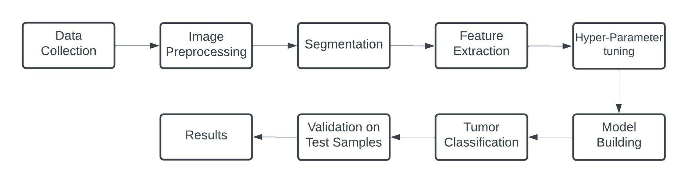

**Figure 1:** Flow of Data In Project

**Chapter 03: IMPLEMENTATION**

**3.1 Date Set Used in the Minor Project**

The dataset used for the proposed project is through Kaggle[12] The dataset has Magnetic Resonance Images of the brain. The project is intended to have a multi-class classification due to which the dataset has 4 classes. The dataset is divided into Training and Testing sets. In the Training set there are 2870 files which consists of 826 files for glioma tumor, 822 files for meningioma tumor and 827 files pituitary tumor and 395 files for no tumor and for Testing set there are 394 files which consists 100 files for glioma tumor, 115 files for meningioma tumor and 74 files pituitary tumor and 105 files for no tumor.

The Training to Testing set ratio used in the proposed model is 88% : 12%.

**3.2 Date Set Features**

**3.2.1 Number of Attributes, description of the data set**

The number of classes in this dataset are 4, three types of tumor meningioma, pituitary and

glioma and one for no tumor. Some visual differences are definitely observed between the types

which resulted from biological differences between them.Glioma is a type of tumor that occurs in

the brain and spinal cord of the human body. Gliomas begin in the gluey supportive cells i.e. glial cells that surround the nerve cells and help them function.In case of Pituitary tumors.A pituitary tumor is a tumor that forms in the pituitary gland near the brain that can cause changes in hormone levels in the body. In meningioma, a tumor that arises from the meninges, the membranes that surround the brain and.spinal cord. it may compress or squeeze the adjacent brain, nerves and vessels

**3.3 Design of Problem Statement**

The design of the problem statement was designed by keeping in mind the severity of the issue.

Brain as it is one of the integral parts of the human body, so its utmost care should be taken.

Brain tumors are considered deadly as they can put pressure on healthy sections of the brain

or spread into certain areas.Some brain tumors are malignant or have the potential to

become cancerous. They can cause complications if they obstruct the flow of fluid surrounding

the brain, resulting in an increase in pressure inside the skull. So their early detection and

classification is very important and models like these that are built with different algorithms help

to determine them accurately.

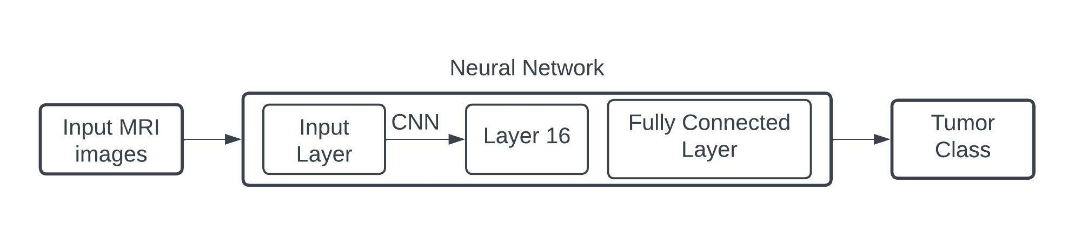

**Figure 2:** Design of Project problem

**3.4 Algorithm and Pseudo code of the Project Problem**

**Pseudo code 1 Pre Processing:**

1. Func create_training_data(): #Function for creating training data array

2. class_num <- category_index #Getting category labels for Images

3. For image in images

4. img_array <- read_image

5. new_array <- resize_image(img_array) #resizing images

6. training_data <- append(new_array,class_num)

**Pseudo code 2 Model Building :**

1. model <- init_sequential()

2. Add input layer

3. Add convolution layer, set filters(64 or 128 or 256), kernel size(3x3 or 5x5),etc

4. Add max pooling layer, set pool size(2x2), etc

5. Add dropout layer, set the dropout percent

6. Repeat steps 3-5 as required

7. Flatten the output of these layers

8. Add dense and dropout layers

9. Get classification as output

**3.5 Flow graph of the Minor Project Problem**

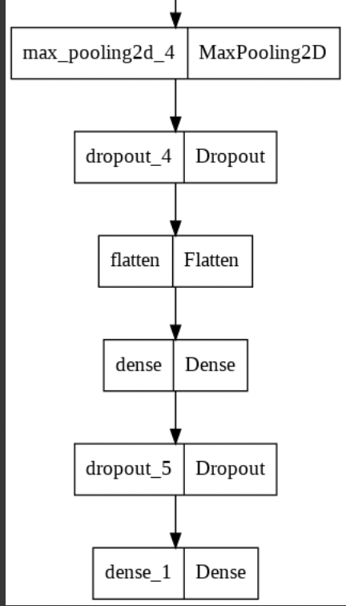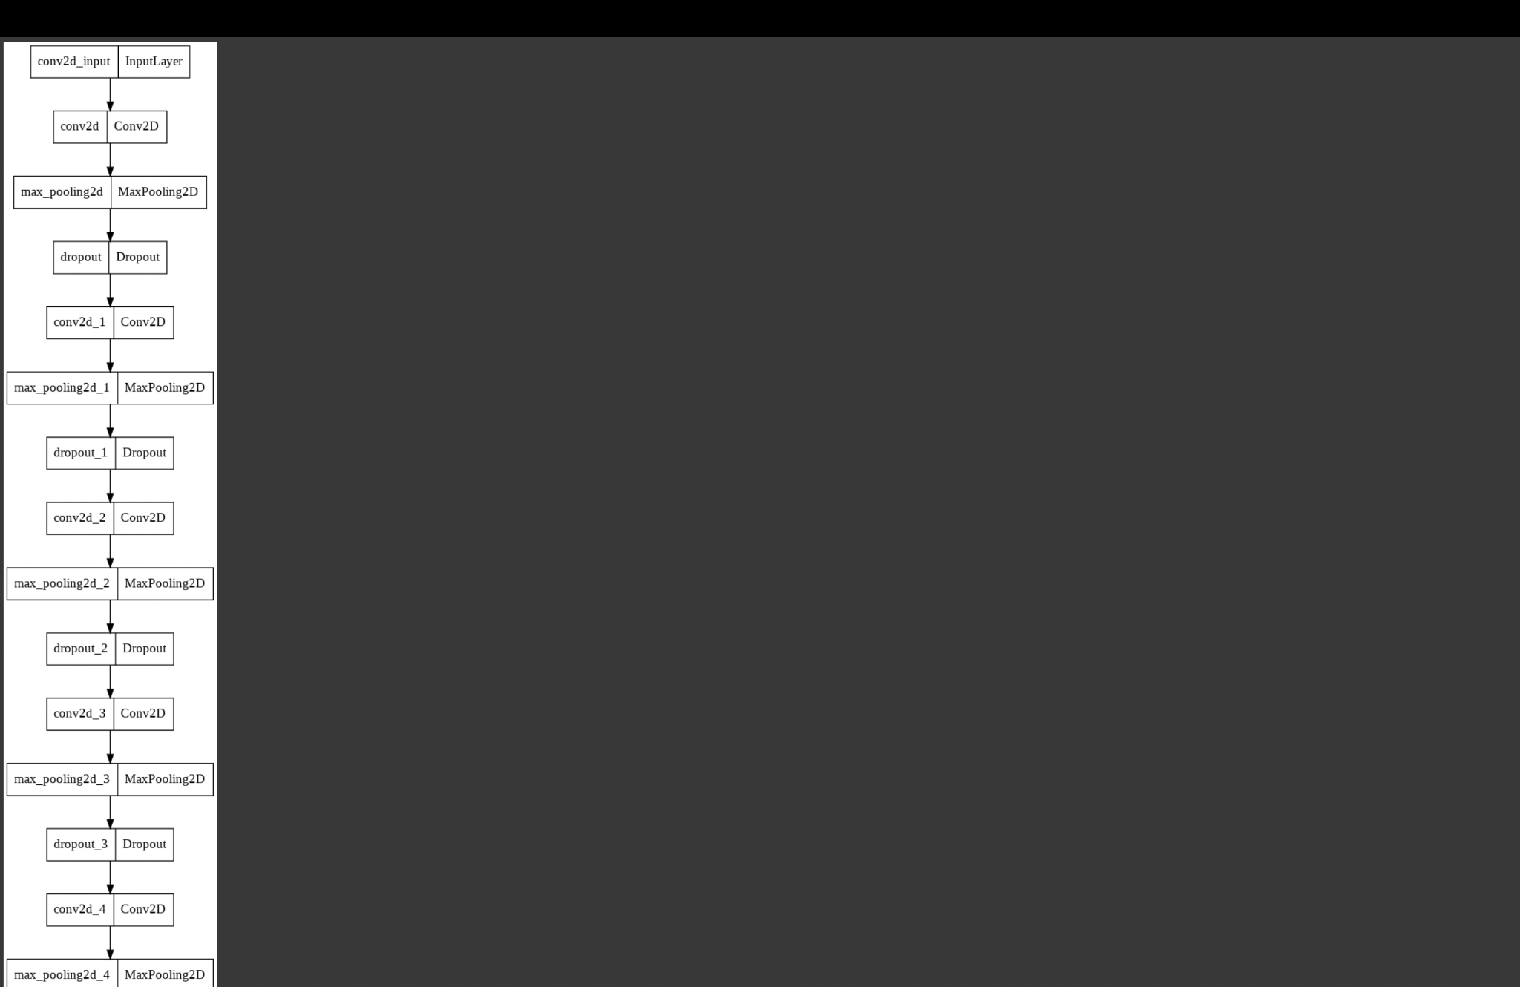

**Figure 3:** Flow of Problem

**3.6 Screenshots of the different phases of the Project**

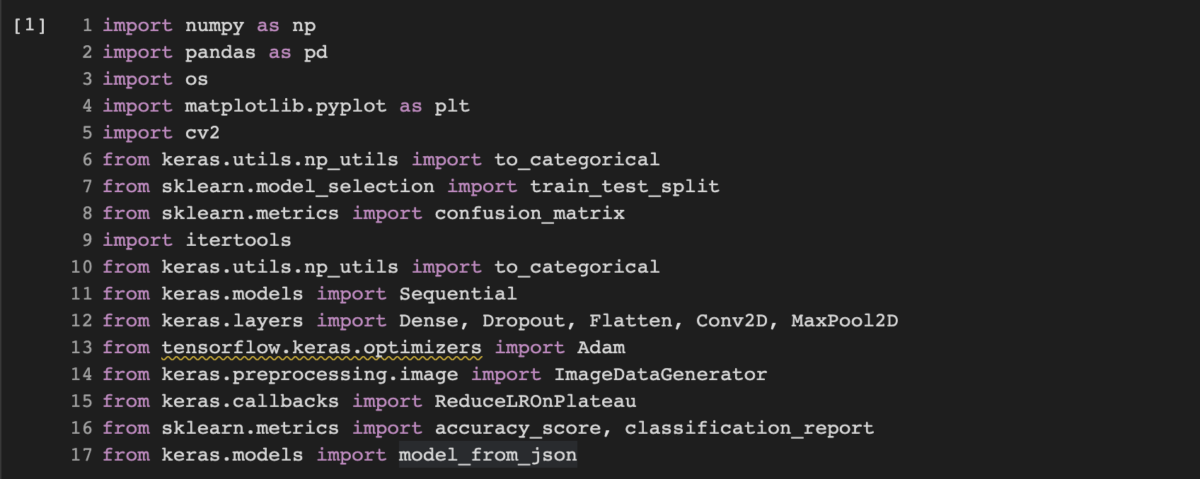

**Figure 4:** Importing all the necessary libraries

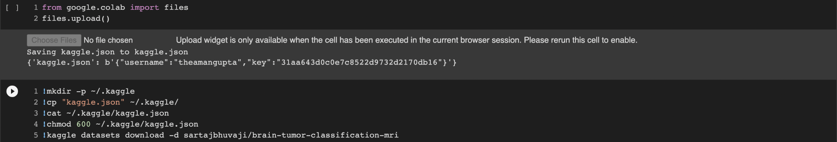

**Figure 5:** Importing dataset from Kaggle

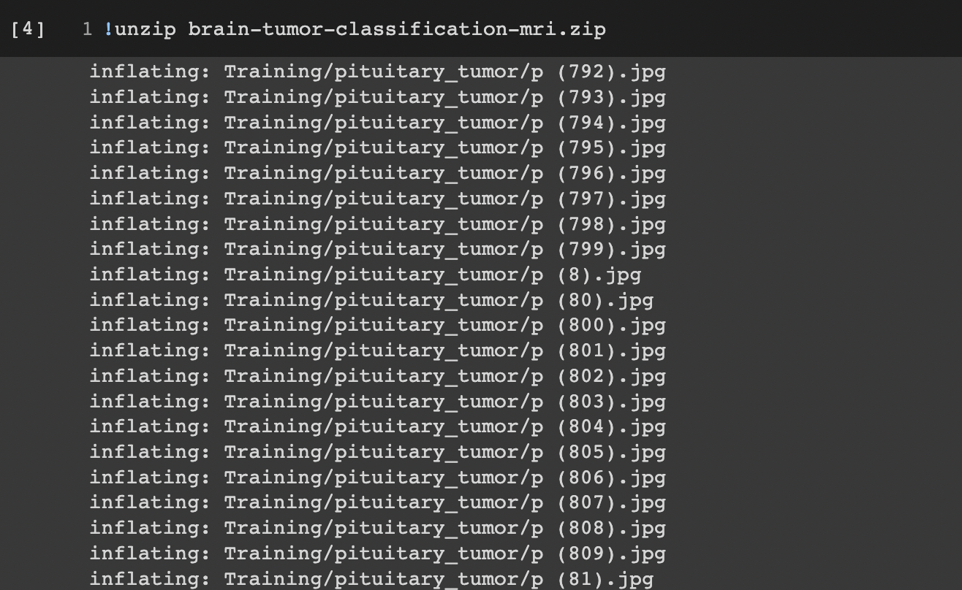

**Figure 6:** Unzipping dataset

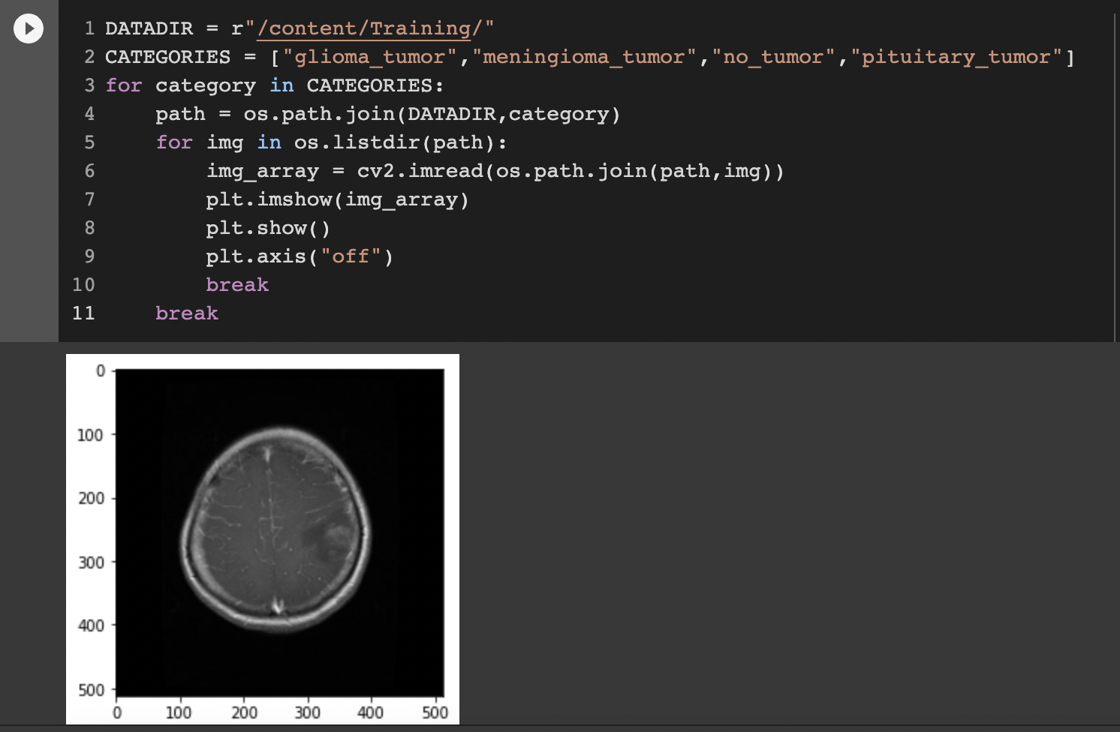

**Figure 7:** Checking a random image in dataset

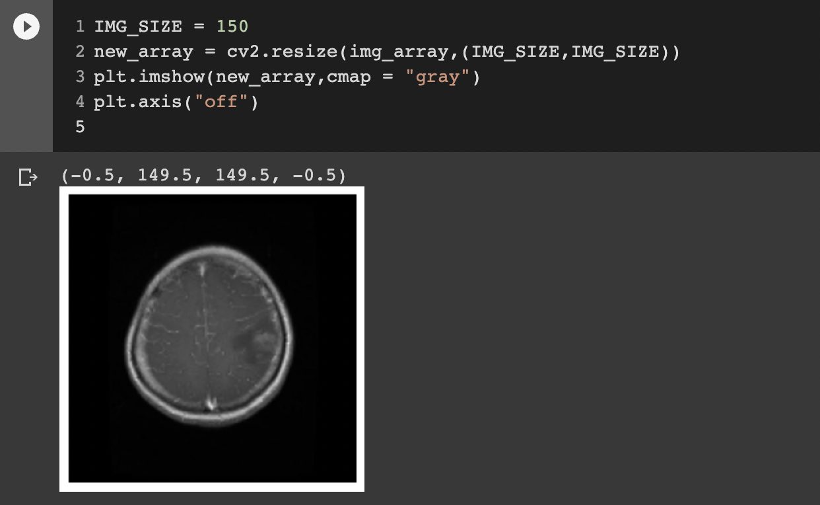

**Figure 8:** Resizing image

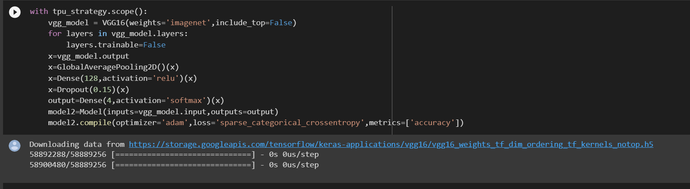

**Figure 9:** Regarding VGG-16

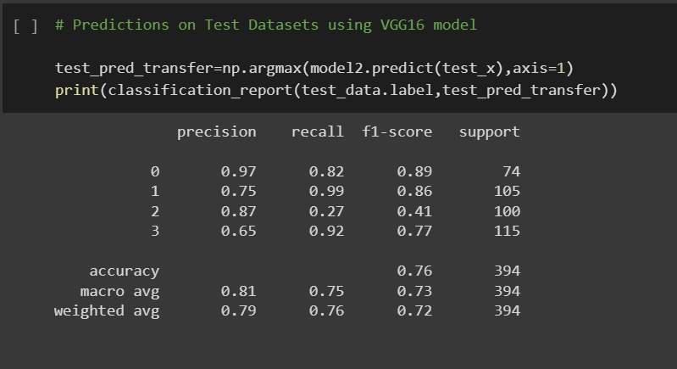

**Figure 10:** Prediction on test datasets using VGG-16

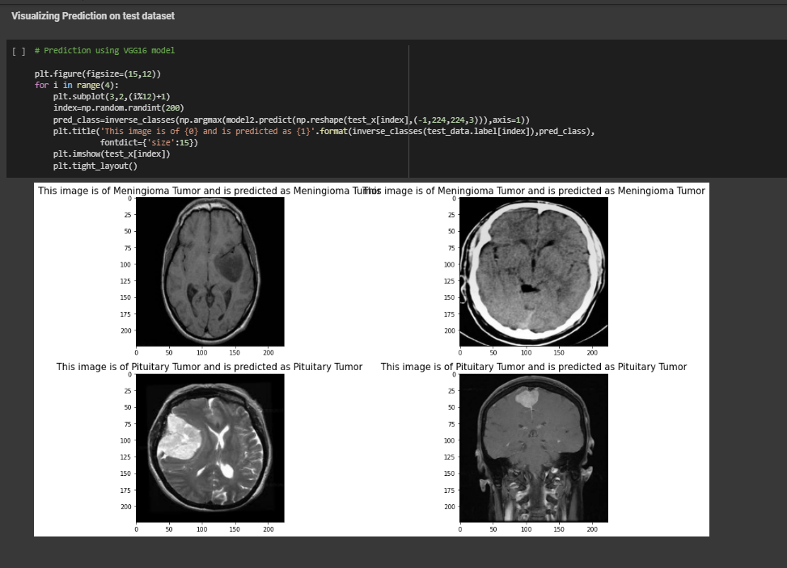

**Figure 11:** Visualizing ofprediction on test datasets using VGG-16

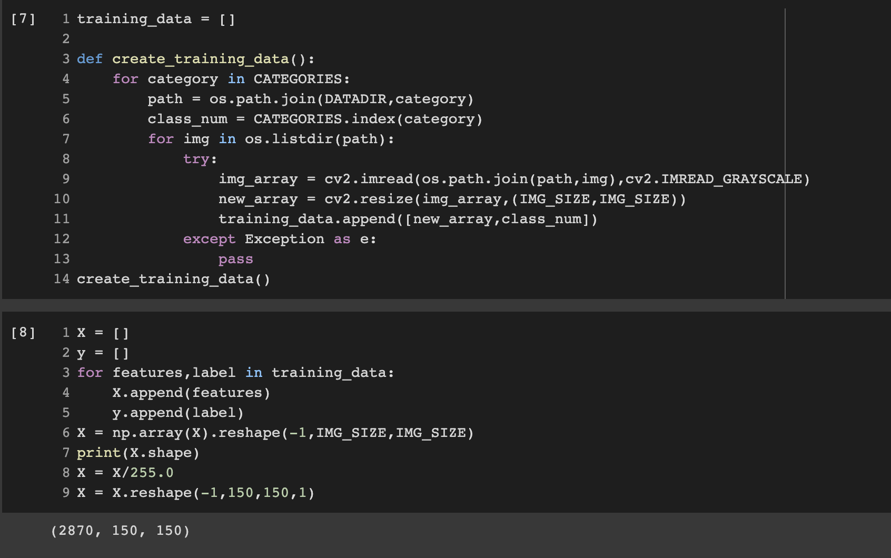

**Figure 12:** Creating training image dataset

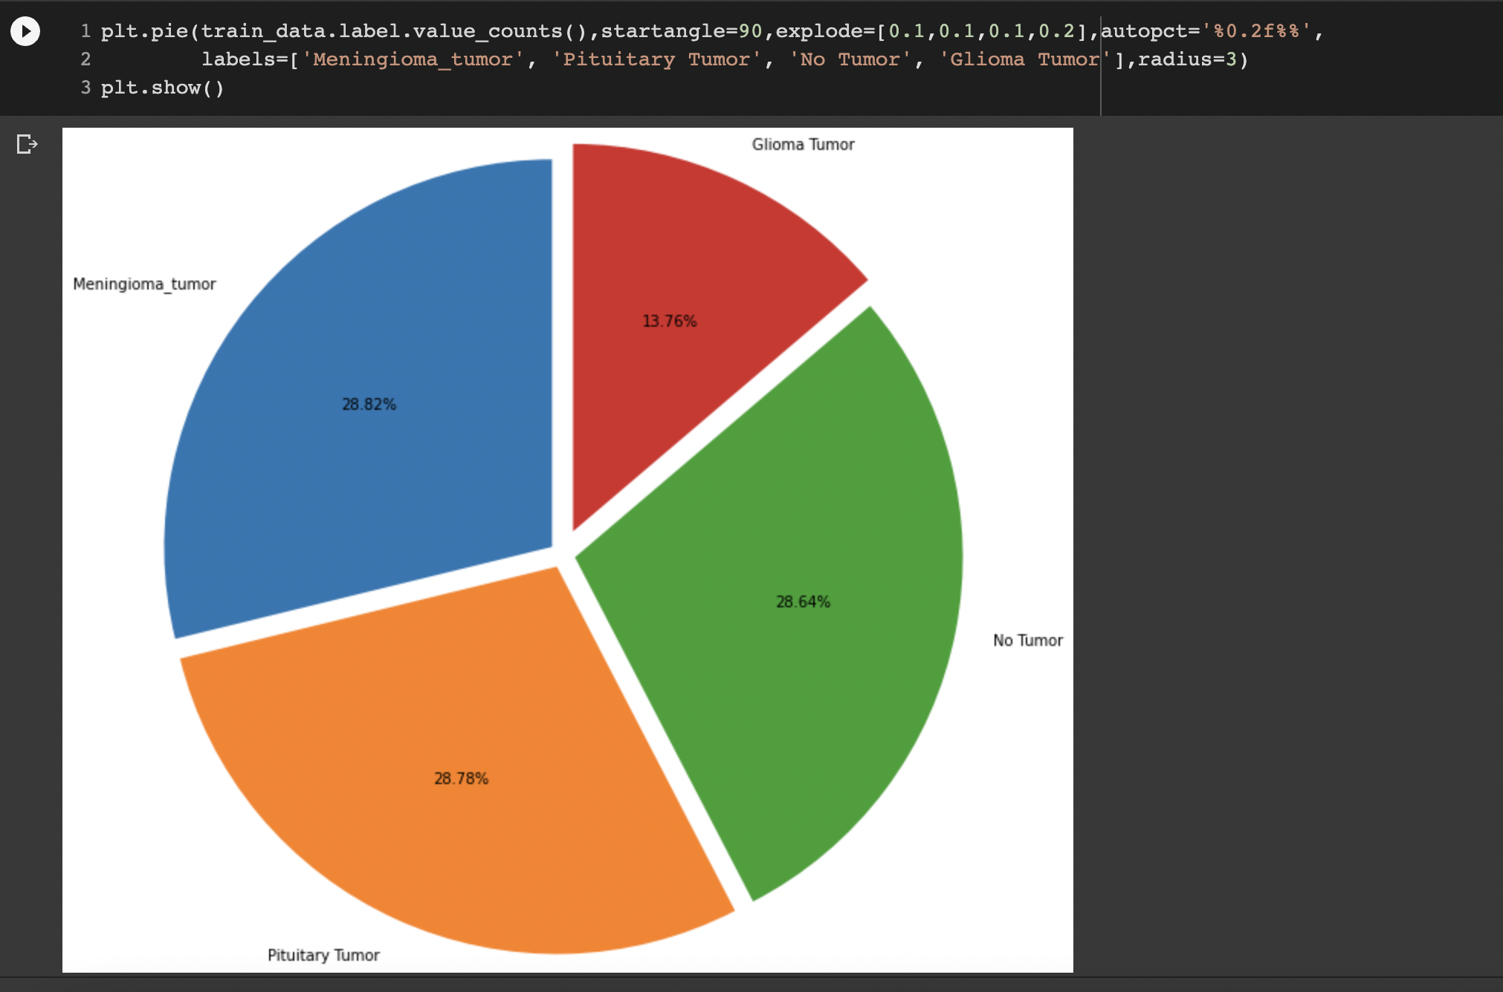

**Figure 13:** Training Dataset Splits for all the types of Brain Tumor

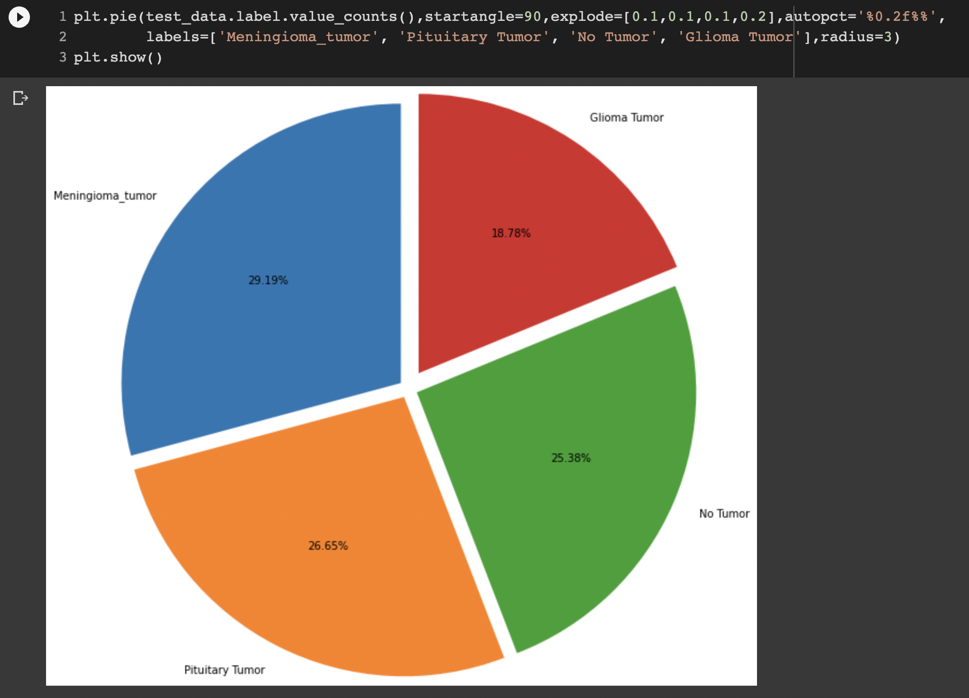

**Figure 14:** Testing Dataset Splits for all the types of Brain Tumor

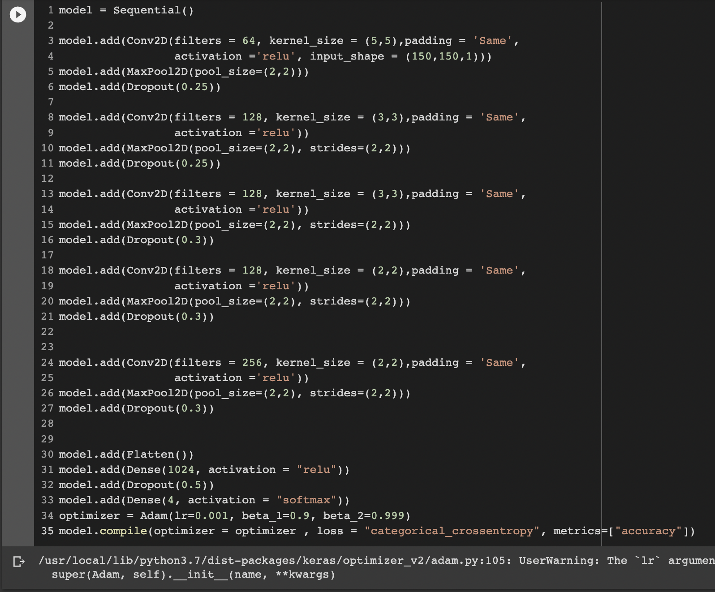

**Figure 15:** Creating CNN model

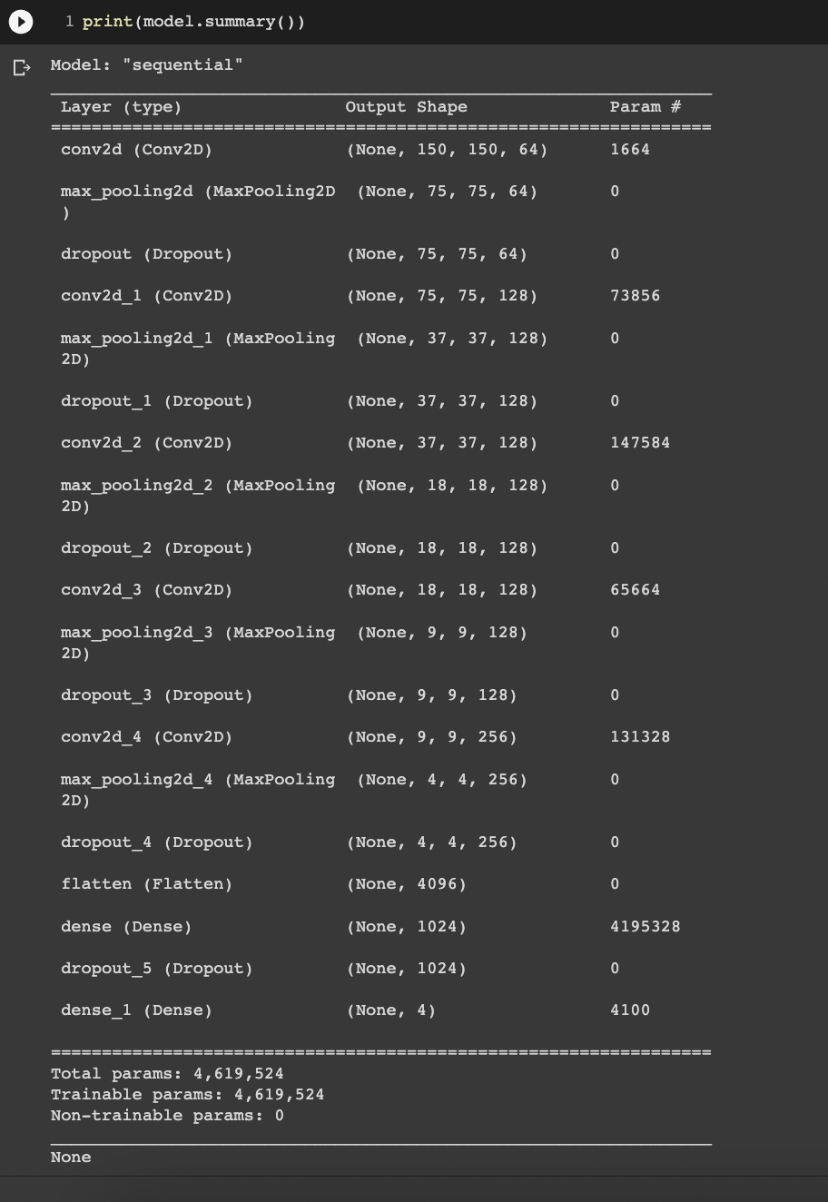

**Figure 16:** Model Summary

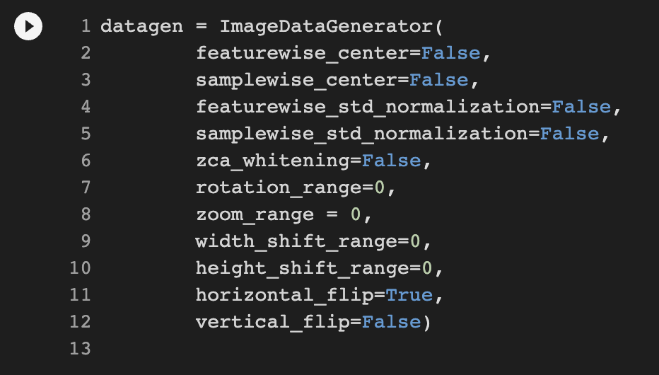

**Figure 17:** Transforming the dataset



**Figure 18:** Setting the Epochs and Batch size for training the model

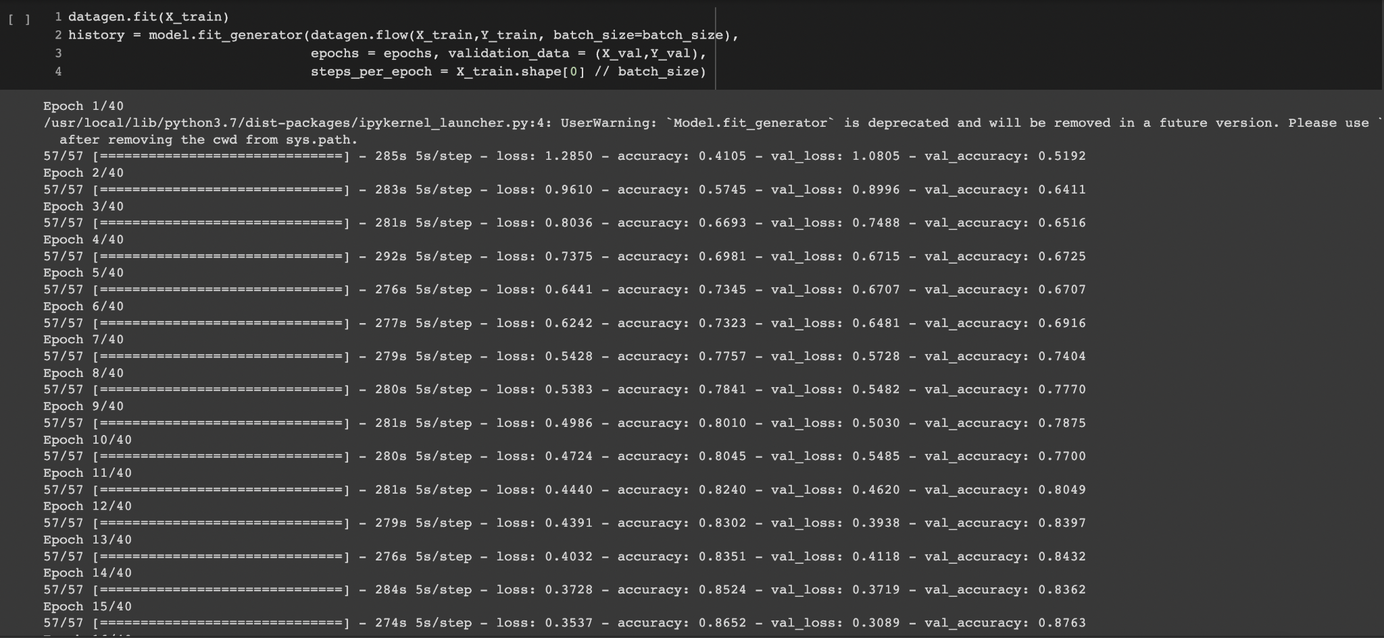

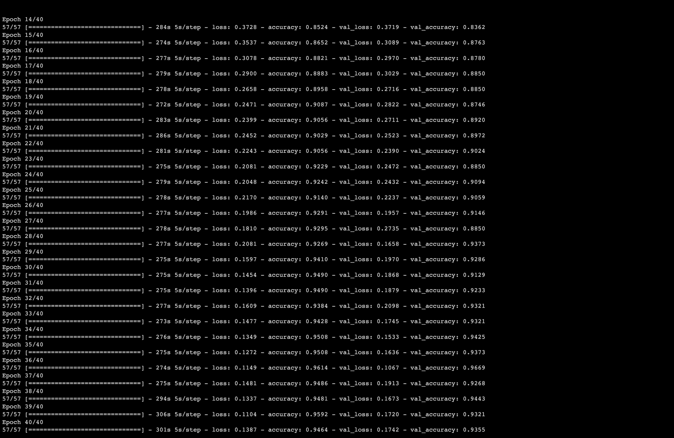

**Figure19-20:** Training the model

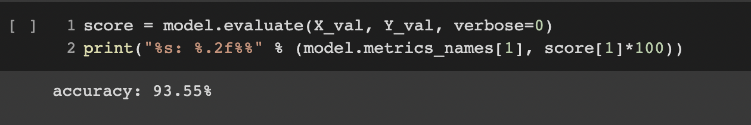

**Figure 21:** Model Accuracy

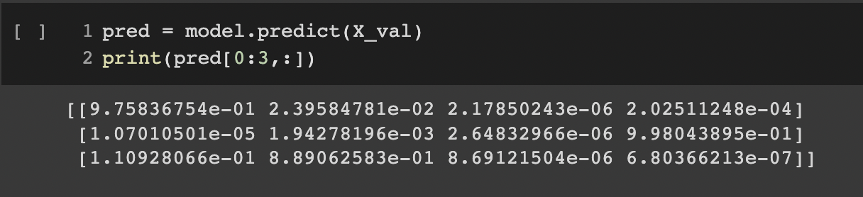

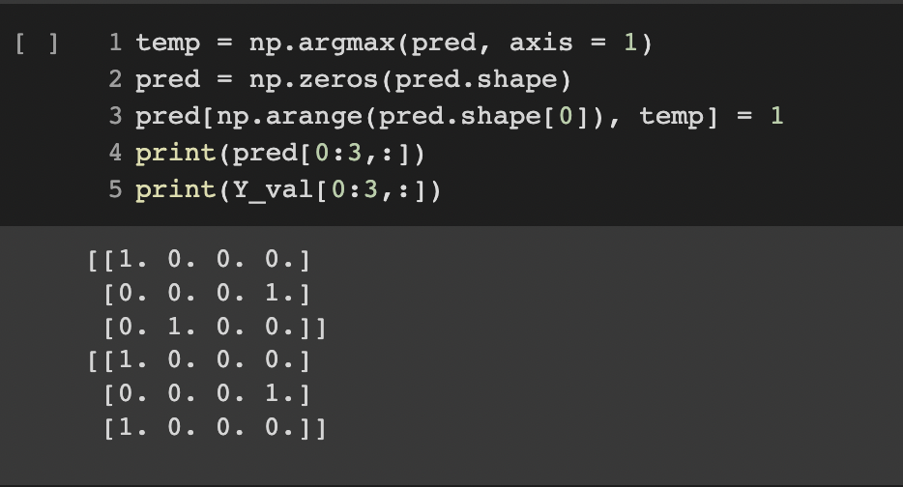

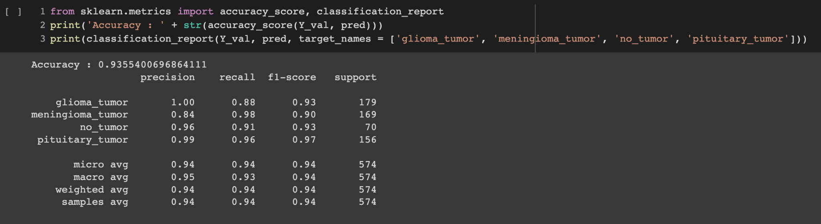

**Figure 22-24:** Predicting Types of brain tumor on Validation set

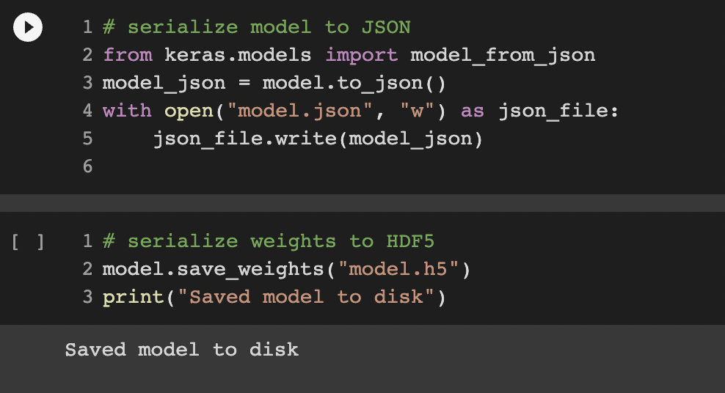

**Figure 25:** Saving model and weights

**Chapter 04: RESULTS**

**4.1 Discussion on the Results Achieved**

During the course of the project, two models VGG-16 and CNN were developed for the same

dataset. The results achieved were basically visualized with help of the performance measures.

Performance metrics are integral to a model's success. Proper analysis can reveal model and architectural obstructions, providing essential information for choosing best algorithms, frameworks and platforms. It further helps in performance optimizations.

Performance parameters used for both VGG-16 and CNN model were accuracy, recall, precision, and F1 score.

Table 1 shows the comparison of different performance measures on VGG-16 and CNN

| **Model Name** | **Accuracy (%)** | **Recall (%)** | **Precision**  **(%)** | **F1-Score**  **(%)** |
| --- | --- | --- | --- | --- |
| **VGG-16** | 76 | 75 | 81 | 73 |
| **CNN** | 93.558 | 93 | 95 | 94 |

**Table: 1** Comparison of Performance Measures

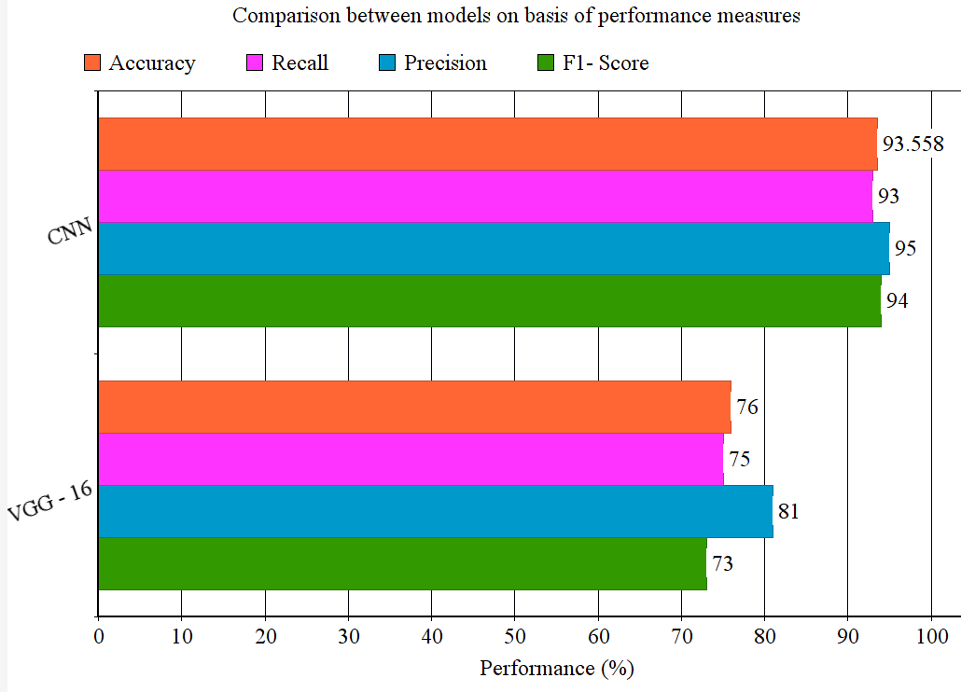

**Figure 26:** Comparison graph of classification Techniques

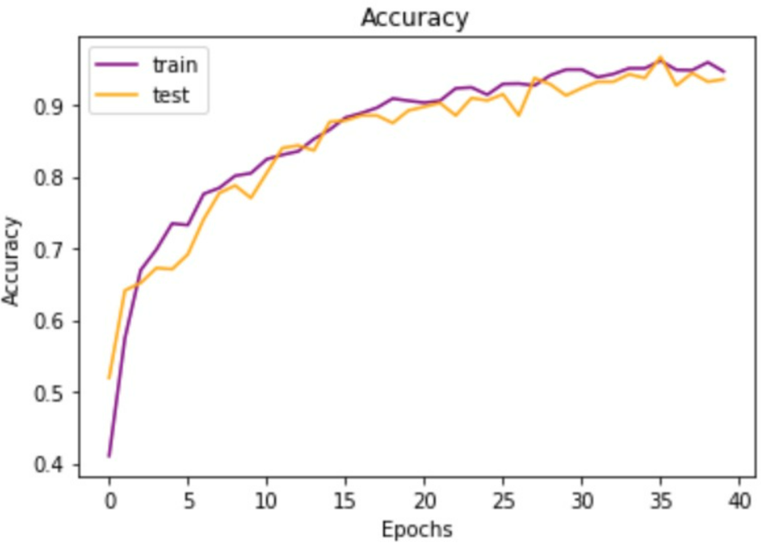 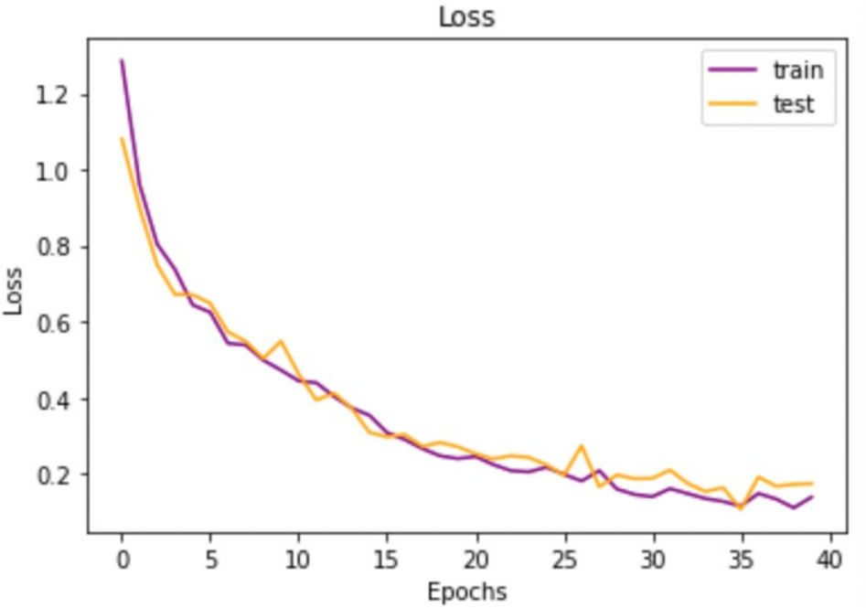

**Figure 27-28:** Validation accuracy and Validation loss for Testing and Training in case of CNN

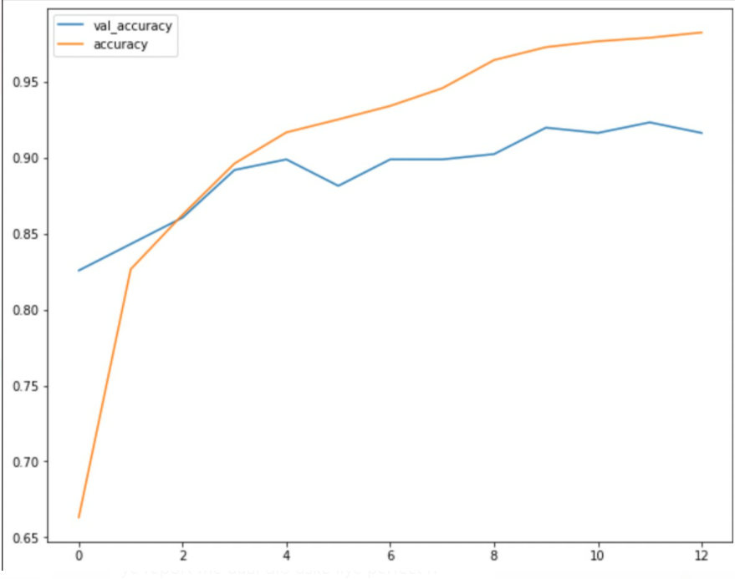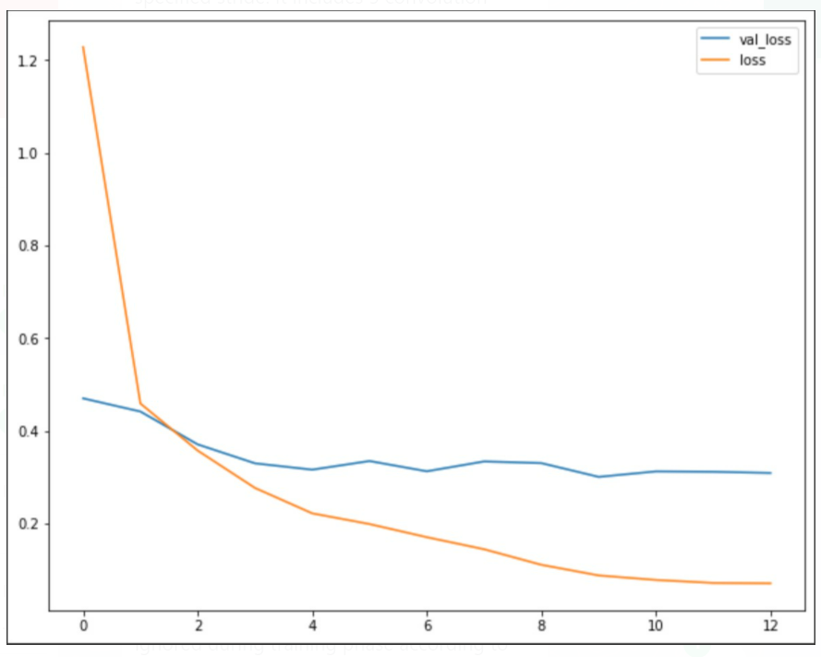

**Figure 29-30:** Validation accuracy and Validation loss for Testing and Training in case of VGG-16

With the help of above experimental results that are performance parameters and the graphs observed for accuracy and loss, it deduced how well VGG-16 and CNN performed on different criteria. With the help of the comparisons drawn, the results could be drawn that CNN has outperformed VGG-16 which is a keras pre-trained model.

**4.2 Application of the Minor Project**

The domain of minor projects is in the field of medical sciences. The aim of the project is to accurately detect and further on classify the brain tumor into its types. The major application would be for hospitals and clinics, this project would help doctors to accurately evaluate the severity, position and type of tumor and provide treatment immediately. With the help of this model patients can also be highly involved in the starting procedures and they can be kept in a loop. The application of this project also extends to the field of research, further developments in types and its differentiations could be easily observed with the help of this model. The model could be easily also understandable to lay man as well with the constraint that MRI images should be available.

**4.3 Limitation of the Minor Project**

There are few minor limitations associated with the project:

* As the project provides better accuracy for CNN, so when taken that into consideration

It gives high computational complexity because of its several layers and also is significantly lower due to an operation such as maxpool.

* If the system on which the model is being executed, would take a lot of time if it doesn't consist of a good GPU.
* One of the disadvantages of MRI diagnostic methods is that they are tedious and are prone to blunders while sampling.

**4.4 Future Work**

* For hospitals and clinics, an app-based user interface may be developed that would allow clinicians to quickly evaluate the impact and type of tumor and provide therapy accordingly, while also allowing patients to be actively involved in the procedure.
* Since the model's exhibition and intricacy are subject to the information portrayal, new procedures, for example, volume-based 3D pictures, will help with foreseeing the cancer's area and stage. Working with 3D physical models made by patients, preparing and arranging them would be quite helpful. Technological direction during medical procedures would lead to completely improved and providing patients with better ordeal.
* Using approaches such as classifier boosting, continue to improve testing accuracy, efficiency, and computing time. It could be accomplished by employing a larger number of images with more data augmentation, training for a prolonged period of time with a larger number of epochs, fine-tuning the model's hyper parameters, adding more relevant layers, and so on. Classifier boosting is a method that requires laying out a model from training information and afterwards making a second model that looks to correct the shortcomings in the primary model for quicker forecast.
* In the case of complicated datasets, the adoption of U-Net design instead of CNN design, in which the layers like max pooling are simply supplanted by up sampling layers, is strongly suggested and could be opted for.
* Unsupervised transfer learning has a lot of potential in the future and is attracting increasing academic interest.

**References**

[1]Badža, M. M., & Barjaktarović, M. Č. (2020). Classification of Brain Tumors from MRI Images Using a Convolutional Neural Network. Applied Sciences, 10(6), 1999. doi:10.3390/app10061999.

[2] Irmak, E. (2021). Multi-Classification of Brain Tumor MRI Images Using Deep Convolutional Neural Network with Fully Optimized Framework. Iranian Journal of Science and Technology, Transactions of Electrical Engineering, 45(3), 1015–1036. doi:10.1007/s40998-021-00426-9.

[3] Krizhevsky, A., Sutskever, I., & Hinton, G. E. (2017). ImageNet classification with deep convolutional neural networks. Communications of the ACM, 60(6), 84–90. doi:10.1145/3065386.

[4] Khan HA, Jue W, Mushtaq M, Mushtaq MU. Brain tumor classification in MRI image using convolutional neural network. Math. Biosci. Eng. 2020 Sep 1;17(5):6203-16.

[5] Szegedy C, Liu W, Jia Y, Sermanet P, Reed S, Anguelov D, Erhan D, Vanhoucke V, Rabinovich A. Going deeper with convolutions. InProceedings of the IEEE conference on computer vision and pattern recognition 2015 (pp. 1-9).

[6] He, K., Zhang, X., Ren, S., & Sun, J. (2016). Deep Residual Learning for Image Recognition. 2016 IEEE Conference on Computer Vision and Pattern Recognition (CVPR). doi:10.1109/cvpr.2016.90

[7] Amin, J., Sharif, M., Yasmin, M., & Fernandes, S. L. (2017). A distinctive approach in brain tumor detection and classification using MRI. Pattern Recognition Letters. doi:10.1016/j.patrec.2017.10.036.

[8] Rehman, A., Khan, M. A., Saba, T., Mehmood, Z., Tariq, U., & Ayesha, N. (2020). Microscopic brain tumor detection and classification using 3D CNN and feature selection architecture. Microscopy Research and Technique. doi:10.1002/jemt.23597.

[9] Simonyan K, Zisserman A. Very deep convolutional networks for large-scale image recognition. arXiv preprint arXiv:1409.1556. 2014 Sep 4.

[10] Salem Ghahfarrokhi, S., & Khodadadi, H. (2020). Human brain tumor diagnosis using the combination of the complexity measures and texture features through magnetic resonance image. Biomedical Signal Processing and Control, 61, 102025. doi:10.1016/j.bspc.2020.102025.

[11] Das, S., Aranya, O. F. M. R. R., & Labiba, N. N. (2019). Brain Tumor Classification Using Convolutional Neural Network. 2019 1st International Conference on Advances in Science, Engineering and Robotics Technology (ICASERT). doi:10.1109/icasert.2019.8934603.

[12] Bhuvan, S. (2020). [Brain Tumor Classification (MRI)] [Data Set]. Kaggle.